steps to run orxApp in android with ndk
this doc only focus on How to create a new activity as quick and easy as possible.
Other extentions and features needs to learn more about jni and orx.

1. download the newest version of android sdk and ndk from http://developer.android.com Or in China, it can be downloaded from a minor like http://androidappdocs.appspot.com/index.html.
if in Windows you should download the cygwin to simulate gcc environment,
while in mac and linux based on gcc directly use ndk you are able to add ndk folder into the path of system optionally

Besides, eclipse plugin adt also need to be updated, you can check the development website of android and get more infomation about how to update adt on eclipse.
note that some features now need ndk r5 to support

2. build a new android project in eclipse, like what it does below.
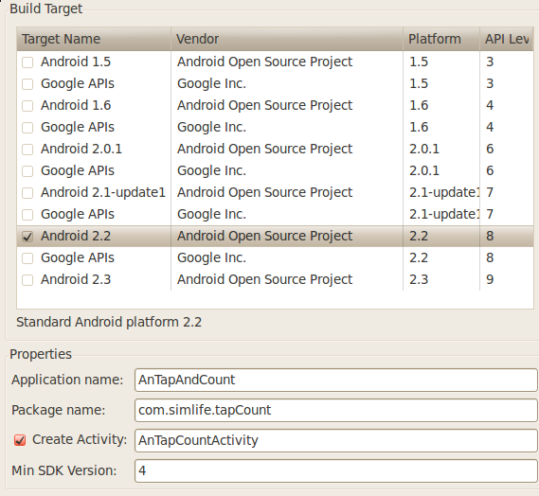

here the AnTapCountActivity is the activity we want to create and is the main and launch activity.
the minisdk had better as low as possible to satisfy more users' need.
but the build target could be high even android 2.3

in AndroidManifest.xml
1. add the activity into this android configuration file. the example is below

<activity android:name="..AnTapCountActivity" android:label="@string/app_name"
android:screenOrientation="portrait"
android:theme="@android:style/Theme.Black.NoTitleBar.Fullscreen">
<intent-filter>
<action android:name="android.intent.action.MAIN" />
<category android:name="android.intent.category.LAUNCHER" />
</intent-filter>
</activity>

here set AnOrxActivity as main and launch activity. The detail about AndroidManifest.xml you need to learn more about android sdk.
android:screenOrientation="portrait" set the screen orientation. if no result it won't be fixed. so it is asked to assign avalue. landscape or portrait
pay attention to <uses-sdk android:minSdkVersion="4" />
it state the mini sdk version, here is 4 android 1.6 which can almost satisfy all of users.

3. put some essential sources and resource into the project.
a. add external jar in the project
the jar lies in the /path/to/orx/code/lib/android named orxJava.jar.
Set your project's build path>configure Build Path as follows:
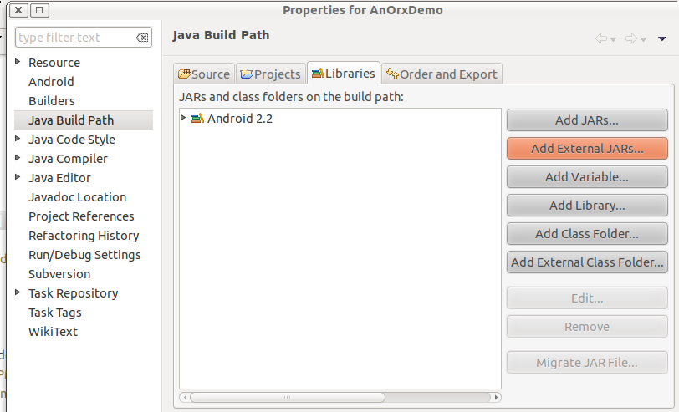

add the external Jars and select where the jar is in the dialog.(at the /path/to/orx/code/lib/android named orxJava.jar)

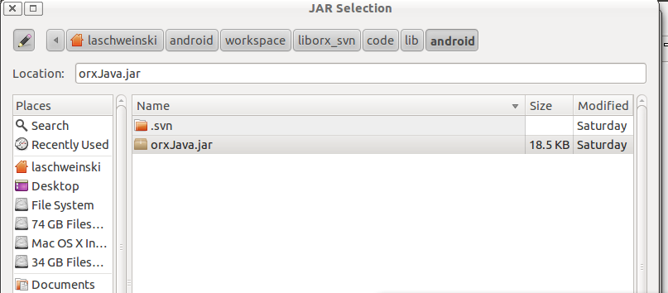

b. (optionally) copy and paste the headers and lib of orx from the orx release folder to your project, the path of it could be defined by yourself, but you should modify the Android.mk as what I describe the next section.
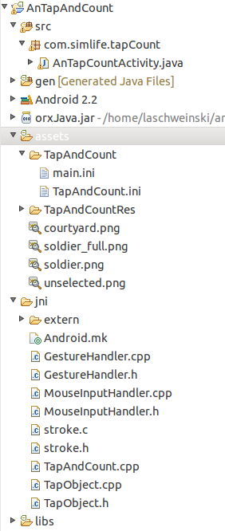
note that you could also link to the lib in the orx release folder. in this case, no any move need to be applied. But some configuration has to set, same as the next section direct.

c. The external resource.
Since the asset folder in the apk wound not have write permissions, those who has to write data into like config files(.ini) has to put in the sdcard, while asset folder will contain other resource such as image and music. Besides some regulation still need to conform with.

1. Creating a folder whose name must equal to what the orx activity specify(will do some introducing later.) and copy all the .ini config files into it. This folder will be moved to the sdcard at the very beginning of the application.
2. copy all other external files such as images into the asset folder. Orx application will load the image from it.
the current tree structure of your project would like the right side.

4. do some modification according to your project
a. in Android.mk
1. ORX_MODULE_NAME the name of ndk lib for this application of orx.
for instance: when the library you set is orxFoo, the lib compiled out is liborxFoo.so, while the java loading is also altered as orxFoo
2. ORXAPP_SRCS the paths of sources this application need to be compiled.
if all of source are needed, you can simply assign *.cpp *.c to this.
3. ORXLIB, ORXINCLUDE, set the path of orx lib and the orx headers. The base path is in current jni folder (in pc). The android demo takes a good example.
an example assignment is posted below

#the name of the lib
ORX_MODULE_NAME := orxTapAndCount
#set all of sources
ORXAPP_SRCS := *.c *.cpp

ORXLIB := extern/lib/android
ORXINCLUDE := extern/include
BOX2DLIB := extern/Box2D_2.1.3/lib/android
BOX2DORXINCLUDE := extern/Box2D_2.1.3/include
(that is what I've done in my new game tap&count. Here I paste the header and lib of orx into jni/extern/orx)

After these modifications, it is available to compile whole sources by ndk-build. if everything goes smoothly,
the libs will be generated in libs/armeabi/ the terminal result is like this:
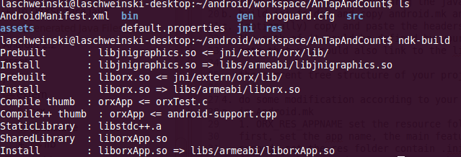
when it is in the debug mode use ndk-build ORX_DEBUG=true -B to compile the application. Moreover, set isDebug parameter in java to true as described below in b.

b. the revision in *Activity (in this case the AnTapCountActivity)
1. it must inherit from AnOrxActivity the activity which is in the jar we introduced before.
2. add onCreate(Bundle savedInstanceState) function like this:
// Setup
protected void onCreate(Bundle savedInstanceState) {
isDebug = false;
//when you need to run in the emulator it should set to true
usingGLES1 = false;
appPath = "bounce_demo";
appName = "orxTest";
orxAppLibName = "orxTapAndCount";

// load the .so lib in AnOrxActivity
super.onCreate(savedInstanceState);

// So we can call stuff from static callbacks
// TODO keep the screen on, I know it is not a perfect decision,
// acticity should resume from pausing.
getWindow().setFlags(WindowManager.LayoutParams.FLAG_KEEP_SCREEN_ON,
WindowManager.LayoutParams.FLAG_KEEP_SCREEN_ON);

//build the gl surface, start to init and run the loop
mSurface = new ORXSurface(this);
setContentView(mSurface);
SurfaceHolder holder = mSurface.getHolder();
holder.setType(SurfaceHolder.SURFACE_TYPE_GPU);
}

note that:
appPath
states the folder name in the asset folder, I mentioned last section, and it stored the config files and other resource tend to have the write permission, and will be moved to sdcard.
AppName
states the name of this app, determine the name of the .ini config which will be loaded by orx automatically.
orxAppLibName:
the name of the lib you generated by ndk; note that when the debug mode is selected, it will add 'd' automatically.
isDebug
state whether it is debug mode, if it is, the lib name used will all be added a 'd', which obey orx's regulation.
UsingGLES1
if set it to true, only opengl lib will be loaded is gles1.0, using the gles1.0 funtion to display all. However, no shader support.
Even set it to false, all devices will display well, orx will choose to load corresponding gles lib at the runtime. But no shader support in the device which only support gles1.0.
mSurface is the surface to create the glContext and the main logic surface to run the whole application.

5. run this android application and enjoy orx development.

enjoy yourself in game development of orx. Thank you.

